**LAB-5**

Muhammad Bilal

(021-18-0037)

1. Write a query in SQL to display the first name, last name, department number, and department name for each employee. (Sample tables: employees & departments)

select e.first_name , e.last_name ,e.department_id , d.department_name from employees e join departments d on e.department_id = d.department_id; 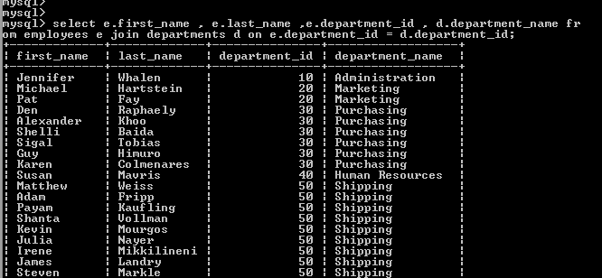

1. Write a query to find the name (first_name, last_name), job, department ID and name of the department who works in London. (Sample tables: employees , locations & departments)

select e.first_name, e.last_name, e.job_id, e.department_id, d.department_name from employees e join departments d on (e.department_id = d.department_id) join locations l on(d.location_id = l.location_id) where lower(l.city) = 'london'; 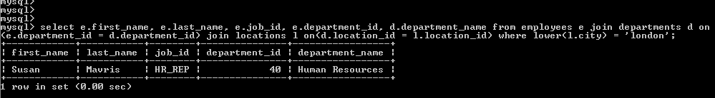

1. Write a query in SQL to display the first and last name, department, city, and state province for each employee. (Sample tables: employees , locations & departments)

select e.first_name,e.last_name, d.department_name, l.city, l.state_province from employees e join departments d on e.department_id = d.department_id join locations l on d.location_id = l.location_id; 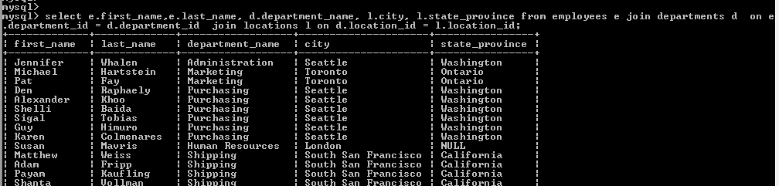

1. Write a query to find the employee id, name (last_name) along with their manager_id and name (last_name). (Sample tables: employees)

select e.employee_id 'emp_id', e.last_name 'employee', m.employee_id 'mgr_id', m.last_name 'manager' from employees e join employees m on (e.manager_id = m.employee_id); 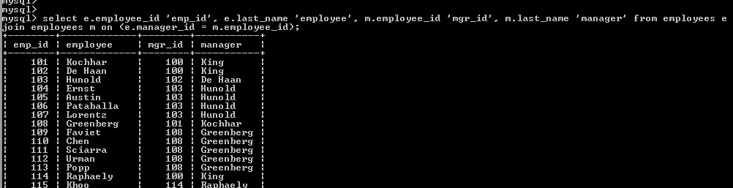

1. Write a query to find the name (first_name, last_name) and hire date of the employees who was hired after 'Jones'. (Sample tables: employees)

select e.first_name, e.last_name, e.hire_date from employees e join employees davies on (davies.last_name = 'jones') where davies.hire_date < e.hire_date; 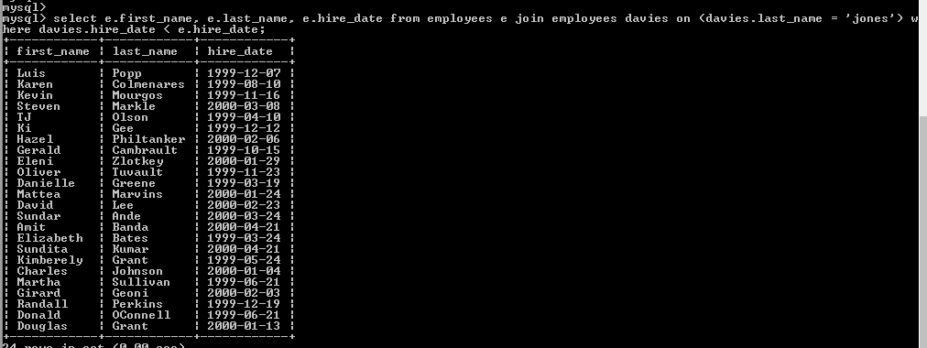

1. Write a query to get the department name and number of employees in the department. (Sample tables: employees & departments)

select department_name as 'department name', count(*) as 'no of employees' from departments inner join employees on employees.department_id = departments.department_id group by departments.department_id, department_name order by department_name; 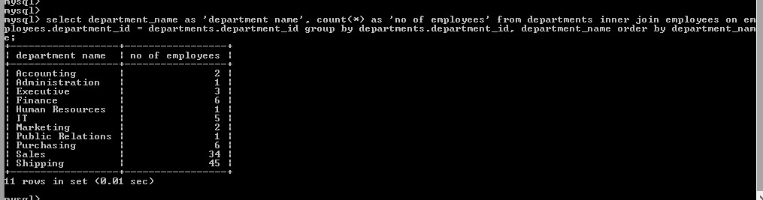

1. Write a query to display the department ID and name and first name of manager. (Sample tables: employees & departments)

select d.department_id, d.department_name, d.manager_id, e.first_name from departments d inner join employees e on (d.manager_id = e.employee_id); 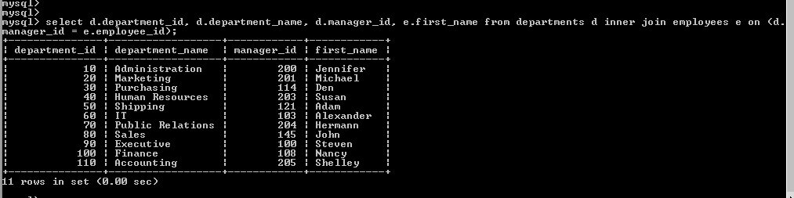

1. Write a query to display the department name, manager name, and city. (Sample tables: employees , locations & departments)

select d.department_name, e.first_name, l.city from departments d join employees e on (d.manager_id = e.employee_id) join locations l using (location_id); 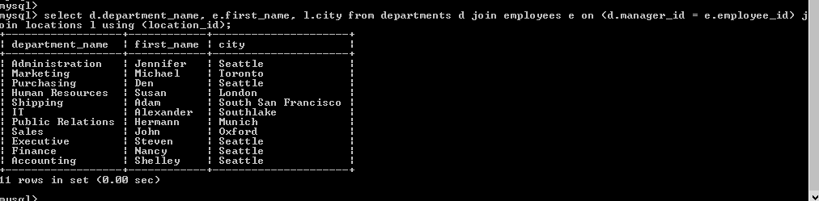

1. Write a query to display the job history that were done by any employee who is currently drawing more than 10000 of salary. (Sample tables: employees & job_history)

select jh.* from job_history jh join employees e on (jh.employee_id = e.employee_id) where salary > 10000; 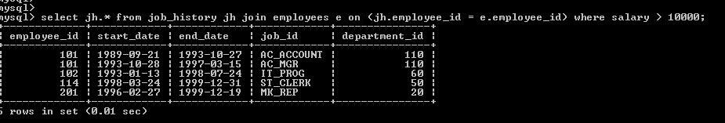

1. Write a query to display the first name, last name, hire date, salary of the manager for all managers whose experience is more than 15 years. (Sample tables: employees & departments)

select first_name, last_name, hire_date, salary, (datediff(now(), hire_date))/365 experience from departments d join employees e on (d.manager_id = e.employee_id) where (datediff(now(), hire_date))/365>15; 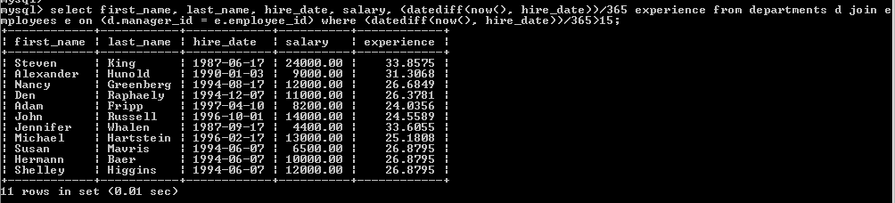

1. Write a query in SQL to display the name of the department, average salary and number of employees working in that department who got commission. (Sample tables: employees & departments)

select department_name, avg(salary), count(commission_pct) from departments join employees using (department_id) group by department_name; 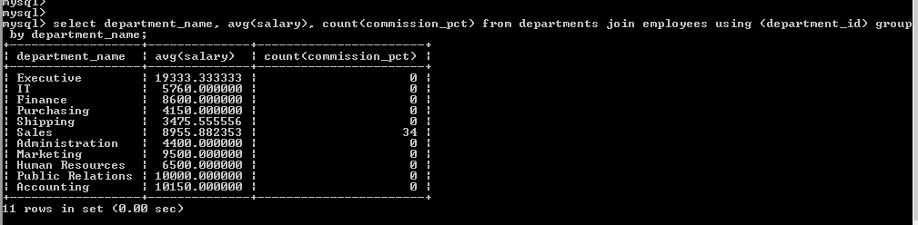

1. Write a query in SQL to display the name of the country, city, and the departments which are running there. (Sample tables: countries , locations & departments)

select country_name,city, department_name from countries join locations using (country_id) join departments using (location_id); 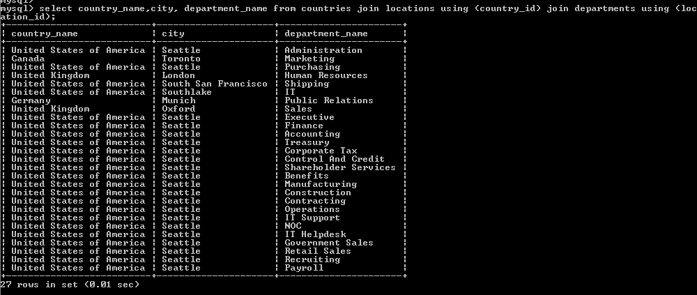

1. Write a query in SQL to display department name and the full name (first and last name) of the manager. (Sample tables: employees & departments)

select department_name, concat(first_name,last_name) as name_of_manager from departments d join employees e on (d.manager_id=e.employee_id) 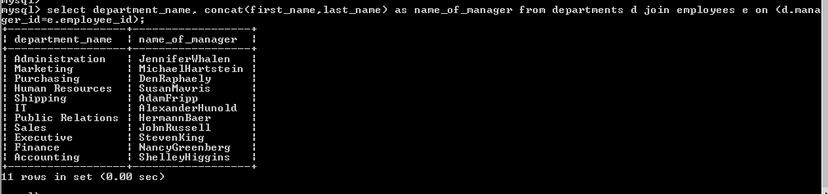

1. Write a query in SQL to display the details of jobs which was done by any of the employees who is presently earning a salary on and above 12000. (Sample tables: employees & job_history)

select a.* from job_history a join employees m on (a.employee_id = m.employee_id) where salary >= 12000; 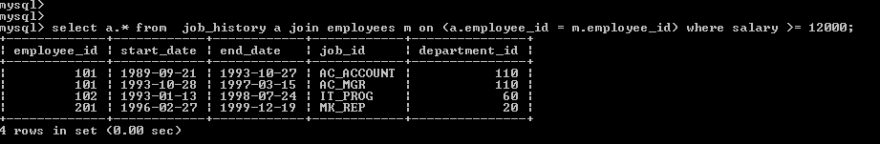

1. Write a query in SQL to display the full name (first and last name), and salary of those employees who working in any department located in London. (Sample tables: employees , locations & departments)

select concat(first_name, last_name) as employee_name, salary from employees join departments using (department_id) join locations using (location_id) where city = 'london'; 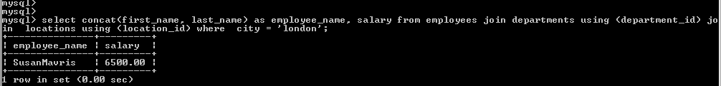

1. Write a query to display job title, employee name, and the difference between salary of the employee and minimum salary for the job. (Sample tables: employees & jobs)

select job_title, first_name, salary-min_salary 'salary - min_salary' from employees natural join jobs; 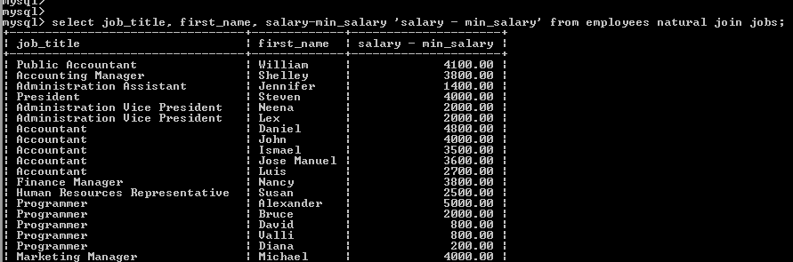

1. Write a query to display the job title and average salary of employees. (Sample tables: employees & jobs)

select job_title, avg(salary) from employees natural join jobs group by job_title; 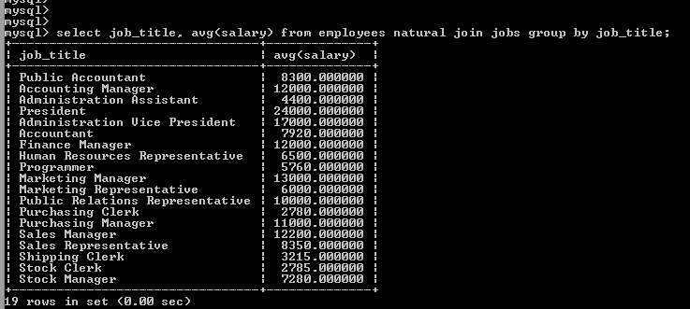

1. Write a query to find the employee ID, job title, number of days between ending date and starting date for all jobs in department 90 from job history. (Sample tables: jobs & job_history)

select employee_id, job_title, end_date-start_date days from job_history natural join jobs where department_id=90; 